CCNP ROUTING AND SWITCHING

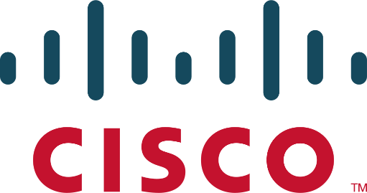

AWS EBS

Instance

B Brennen Tse . 5/27/2022

Task 1: Create a New EBS Volume

1. In the **AWS Management Console** on the top left of the screen, click the **Services** menu then **EC2**.
2. Choose **Instances** in the left navigation pane. (You should see a Lab Instance already launched)
3. Choose **Volumes** in the left navigation pane.
4. Choose Create Volume then configure:
5. 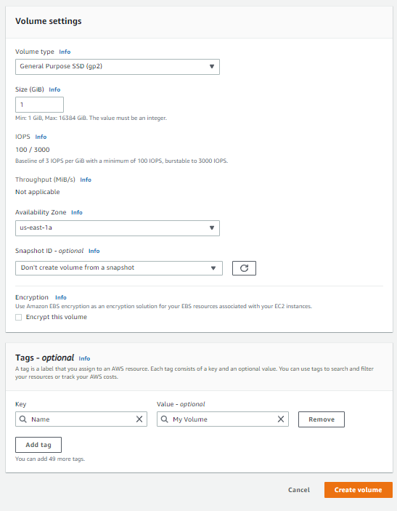

Task 2: Attach the Volume to an Instance

1. Select **My Volume**
2. In the **Actions** menu, choose **Attach volume**
3. Choose the **Instance** field, then select the Lab instance that appears
4. 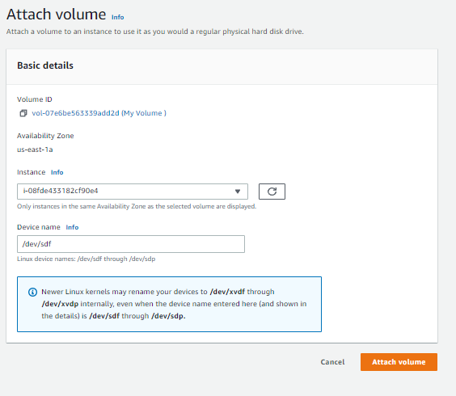

Task 3: Connect to Your Amazon EC2 Instance

Read through the three bullet points in this step before you start to complete the actions, because you will not be able see these instructions when the Details panel is open.

* Choose the Details drop down menu above these instructions you are currently reading, and then choose Show. A Credentials window will open.
* Choose the **Download PPK** button and save the **labsuser.ppk** file. Typically your browser will save it to the Downloads directory.
* Then exit the Details panel by choosing the **X**.

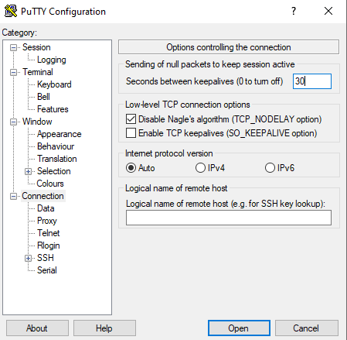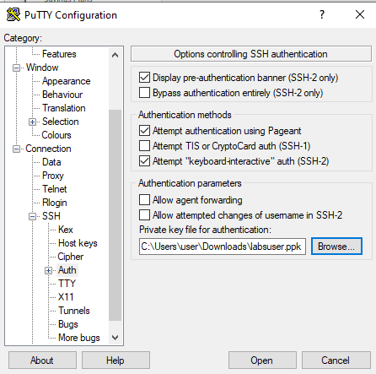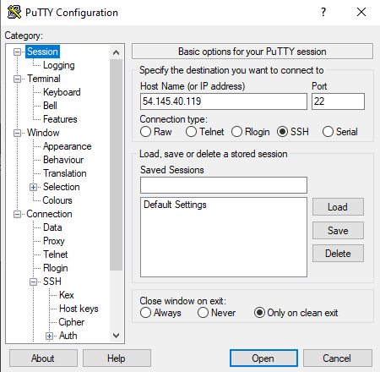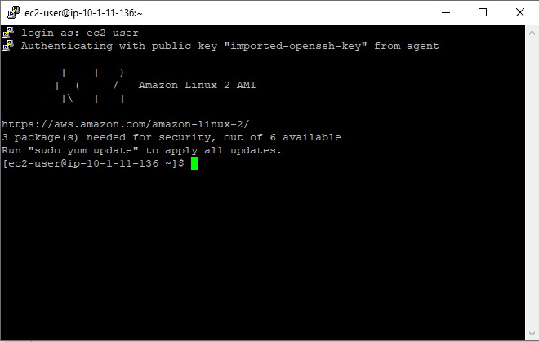

Task 4: Create and Configure Your File System

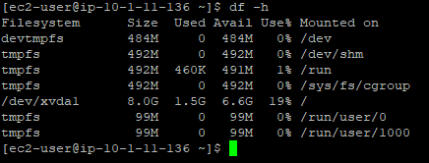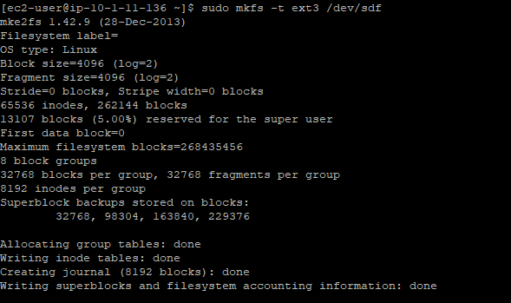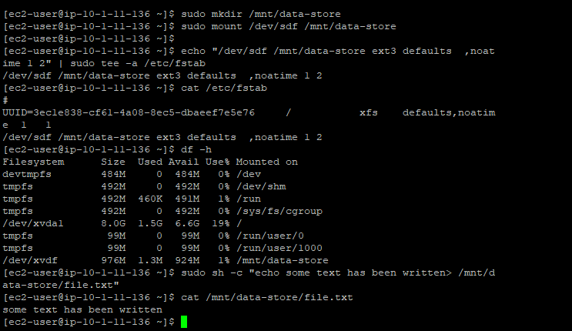

Task 5: Create an Amazon EBS Snapshot

1. In the AWS Management Console, choose Volumes and select My Volume
2. In the Actions menu, select Create snapshot
3. Choose Add tag then

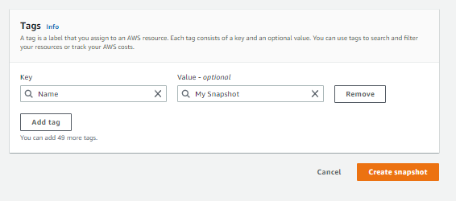

1. Left navigation pane choose Snapshots
2. 

Task 6: Restore the Amazon EBS Snapshot

Create a Volume Using Your Snapshot

1. Select My Snapshot from the AWS Management Console
2. Select Create volume from snapshot in the Actions menu
3. Select Availability Zone
4. 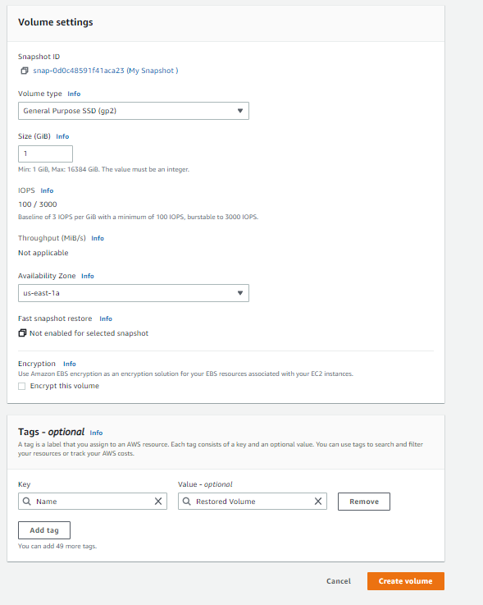
5. Choose Volumes from the left navigation pane
6. Select restored volume
7. 